# **Chapter 5: Risk Management**

Risk Management is process of identifying, analyzing, controlling, and avoiding, minimizing, or eliminating of intolerable risks. In any project risk assumption, risk avoidance, risk retention, risk transfer, or any other strategy (or combination of strategies) should be adopted for proper management of system success. Therefore, risk management is to be performed.

***(what is risk management , 2018)***

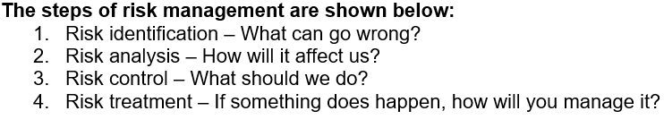

**Likelihood**

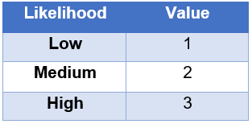

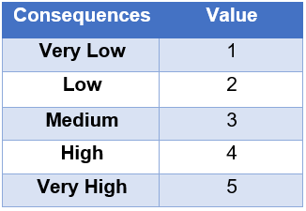**Consequences**

Taking reference from the above Likelihood and Consequences table, we calculate the impact.

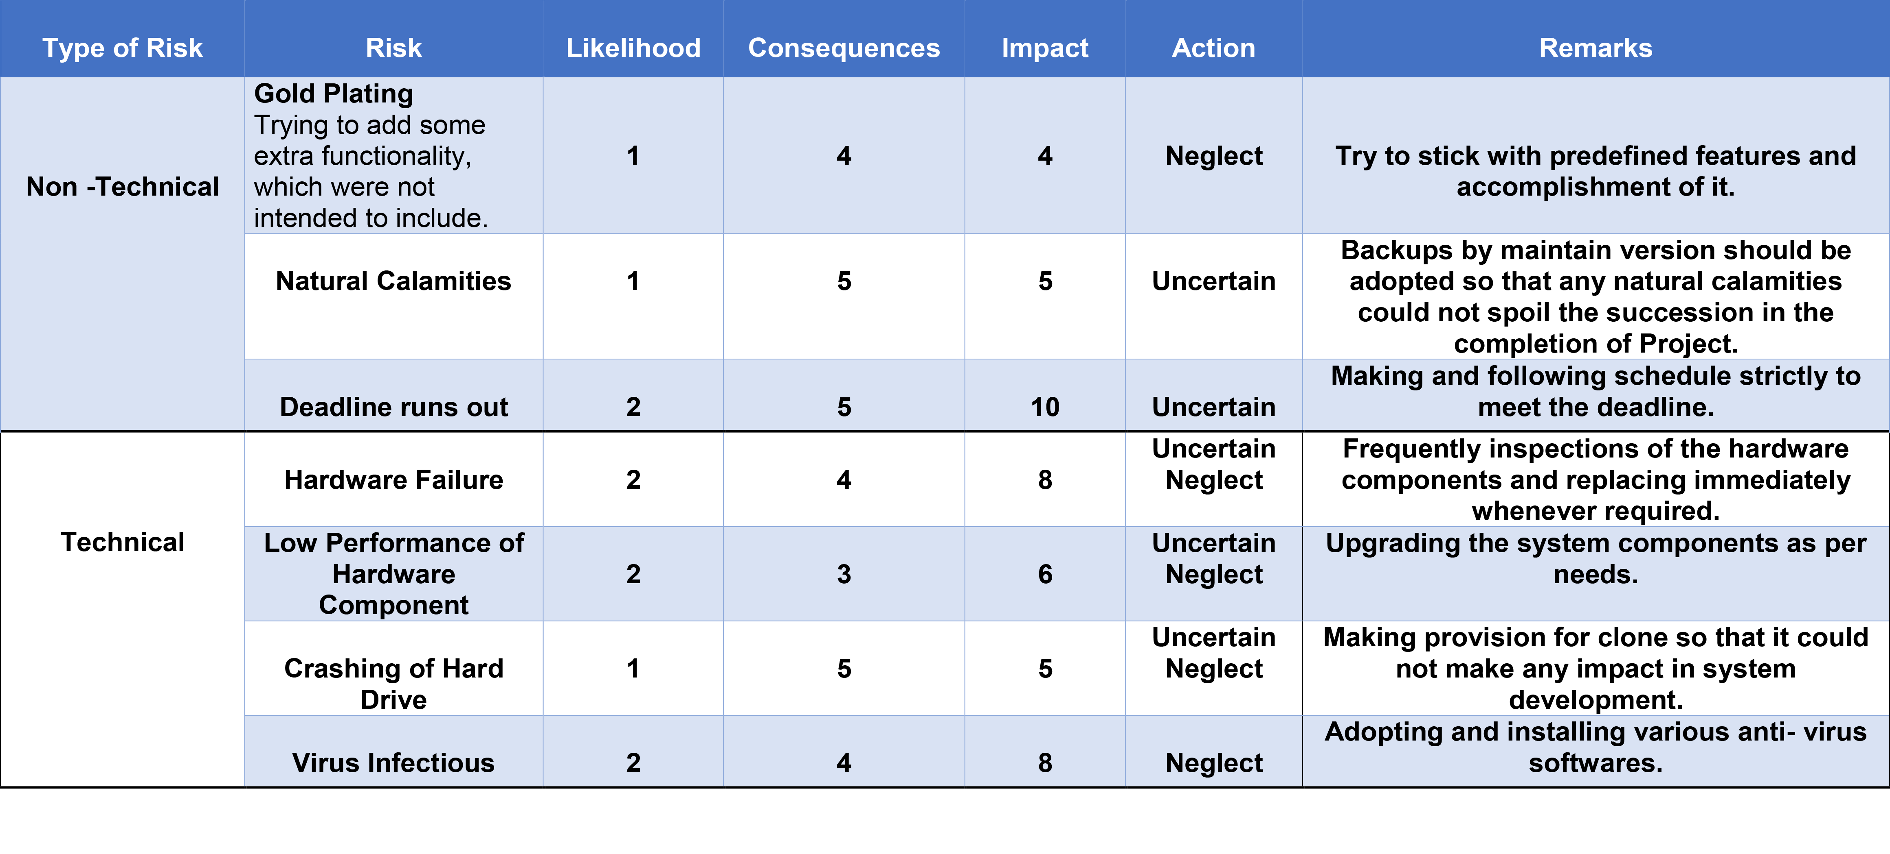

Impact = Likelihood * Consequences

In the table below, we identify some possible non-technical and technical risk that might occur during our project accomplishment.